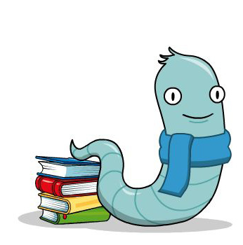
10 Top Tips on Hearing Your Child Read

1. Choose a quiet time
Set aside a quiet time with no distractions. Ten to fifteen minutes is usually long enough.

2. Make reading enjoyable
Make reading fun! Sit with your child. As you read to your child, bring the characters to life – talk about the characters, the drawings and the events so that the story starts to come alive.

3. Keep the flow
If your child says a word wrong try not to interrupt immediately. Instead allow opportunity for self-correction. It is better to tell a child some unknown words to maintain the flow rather than insisting on trying to build them all up from the sounds of the letters.

4. Be positive
If your child says something nearly right to start with that is fine. Don't say 'No. That's wrong,' but 'Let's read it together' and point to the words as you say them. Boost your child's confidence with constant praise for even the smallest achievement.

5. Sounding out

If your child is struggling with a particular word, encourage them to break it up into sounds.

6. Visit the Library
If you can, encourage your child to use the public library.

7. Regular practice and routine
Try to read with your child on most school days if you can. 'Little and often' is best. Teachers have limited time to help your child with reading, and experts have noted that having a routine is key part of reading success at home.

8. Communicate
Try to communicate regularly with positive comments and any concerns in your child’s reading record. Your child will then know that you are interested in their progress and that you value reading.

9. Talk about the books
Always talk to your child about the book; about the pictures, the characters, how they think the story will end, their favourite part. You will then be able to see how well they have understood and you will help them to develop good comprehension skills.

10. Variety is important
Children need to experience a variety of reading materials eg. picture books, hard backs, comics, magazines, poems, and information books.
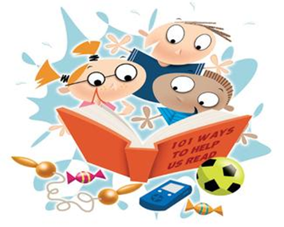
What questions can I ask my child about their book?
• Have we read other books like this? What do you remember about them? How is this character feeling? Why?
• What might happen next?
- Which is your favourite page? Why?

- Can you find me some words beginning with…

- Is this book fiction or non-fiction?

Websites

http://www.phonicsplay.co.uk/InteractiveResources.htm

http://www.oxfordowl.co.uk/for-home/reading-owl/reading

(this website has over 250 free e-books, tablet friendly!)

Apps

Hooked on Phonics Learn to Read

Phonics Genius

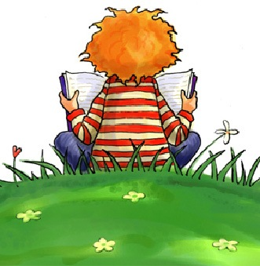
Please remember to bring in your child’s reading book and reading record every Monday and Friday.
Thank you

